

StudyAI

Smart AI Study Companion & Quiz Generator

Project Documentation

Submitted By

Lava Kumar Krish Devarapu(Team Lead)

Roll Number AP24110011950

Department of Computer Science and Engineering

SRM University – AP

Education | Generative AI | Full Stack Web Application

React.js • Python • Flask • Firebase
Groq AI • Llama 3.3 70B • JSON

Internship Partner
SmartBridge SkillWallet Academy

Academic Year
2026–2027
Team Details

S.No | Name | Roll Number | Role | Email
1 | Lava Kumar Krish Devarapu | AP24110011950 | Team Lead | krish_devarapu@srmap.edu.in
2 | Pavankalyan Nanduri | AP24110010564 | Member | pavankalyan_nanduri@srmap.edu.in
3 | Akshaya Kakinada | AP24110011413 | Member | akshaya_kakinada@srmap.edu.in
4 | Aditya Prasad Godigoti | AP24110010822 | Member | adityaprasad_godigoti@srmap.edu.in
5 | Bathala Naga Venkata Sai Santosh |  | Member | santoshbathala@gmail.com

Project Description

StudyAI is a web-based AI-powered study companion and quiz generation platform designed to help students transform notes, textbooks, PDFs, and study materials into structured learning resources. The application enables users to upload study material, generate AI-powered summaries, create interactive flashcards, take personalized quizzes, and receive adaptive study schedules from a single dashboard.
The system is developed using React.js for the frontend, Python Flask for the backend, and Firebase for cloud storage. It integrates the Groq API with the Llama 3.3 70B Versatile model to provide intelligent summarization, flashcard generation, quiz creation, personalized study planning, and adaptive learning recommendations, making exam preparation more efficient and interactive.

Project Objectives

- Develop an AI-powered study companion for students.
- Convert study materials into concise AI-generated summaries.
- Generate interactive flashcards for active learning.
- Create AI-powered quizzes for self-assessment.
- Identify weak topics and improve learning outcomes.
- Generate personalized study schedules based on student performance.
- Store study materials securely using Firebase.
- Provide an intuitive and responsive web interface.

Key Features

- Upload PDF, DOCX, or text-based study materials.
- AI-powered summary generation.
- Interactive flashcard creation.
- Automatic quiz generation (MCQ, True/False, Short Answer).
- Personalized 7-day study planner.
- Performance analytics and weak topic identification.
- Secure cloud storage using Firebase.
- Responsive dashboard with modern UI.

Scenarios
Scenario 1: Uploading Study Material
A student uploads a PDF chapter, DOCX file, or pastes study notes into the application. The system extracts the content, assigns a unique material ID, securely stores the study material in Firebase, and makes it available for AI-powered features such as summary generation, flashcards, quizzes, and study planning.

Scenario 2: AI Summary Generation
After selecting an uploaded study material, the student requests an AI-generated summary. The Groq-powered Llama 3.3 model analyzes the content and produces a structured summary containing topic overviews, key concepts, important definitions, core principles, and revision notes for quick learning.

Scenario 3: Flashcard Generation
The student generates interactive flashcards from the uploaded material. The AI creates question-and-answer pairs with topic labels and difficulty levels. Students can flip cards, mark completed concepts, shuffle flashcards, and monitor their learning progress.

Scenario 4: AI Quiz Generation
The student selects a quiz format such as Multiple Choice Questions, True/False, or Short Answer. The AI generates personalized questions from the uploaded material. After submission, the application calculates the score, provides explanations, highlights weak topics, and stores quiz performance for future analysis.

Scenario 5: Personalized Study Planner
Based on uploaded study material and quiz performance, the AI generates a personalized 7-day study schedule. The planner recommends daily learning tasks, focus topics, study duration, and revision strategies to help students prepare effectively for examinations.

Technical Architecture

Introduction
The StudyAI system follows a modern client-server architecture that combines a React.js frontend, a Python Flask backend, Firebase cloud services, and the Groq AI platform. The frontend provides an interactive user interface, while the backend processes user requests, manages study materials, communicates with Firebase, and integrates with the Groq API to generate AI-powered learning content. This architecture ensures scalability, secure data management, and an efficient learning experience.

Architecture Overview
The application consists of four primary components: the React.js frontend, Flask backend, Firebase cloud database, and Groq AI service. Users interact with the frontend to upload study materials and access learning features. The backend validates requests, processes uploaded content, stores information in Firebase, and sends prompts to the Groq API. AI-generated responses are returned to the frontend for display as summaries, flashcards, quizzes, and personalized study plans.

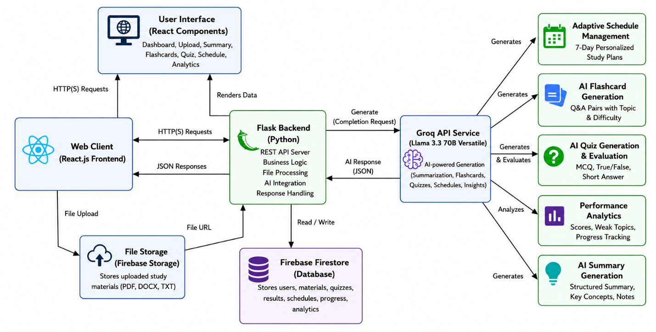

Figure 5.1: StudyAI System Architecture

Pre-requisites

Introduction
The StudyAI project requires a suitable development environment, cloud services, AI integration, and software tools to build and deploy the application successfully. These prerequisites ensure seamless frontend development, backend processing, cloud storage, and AI-powered educational content generation.

Hardware Requirements
- Processor: Intel Core i5 (10th Gen or above) / AMD Ryzen 5 or equivalent
- RAM: Minimum 8 GB (16 GB Recommended)
- Storage: 256 GB SSD minimum (512 GB Recommended)
- Internet Connection: Stable broadband connection (10 Mbps or higher)

Software Requirements
- Operating System: Windows 10/11, macOS, or Linux
- Visual Studio Code
- Python 3.11+
- Node.js & npm
- Git and GitHub
- Google Chrome / Microsoft Edge
- Firebase Console
- Groq Cloud Platform

Technologies Used
- React.js
- Python Flask
- Firebase Firestore
- Firebase Storage
- Groq API
- Llama 3.3 70B Versatile
- HTML5
- CSS3
- JavaScript
- JSON

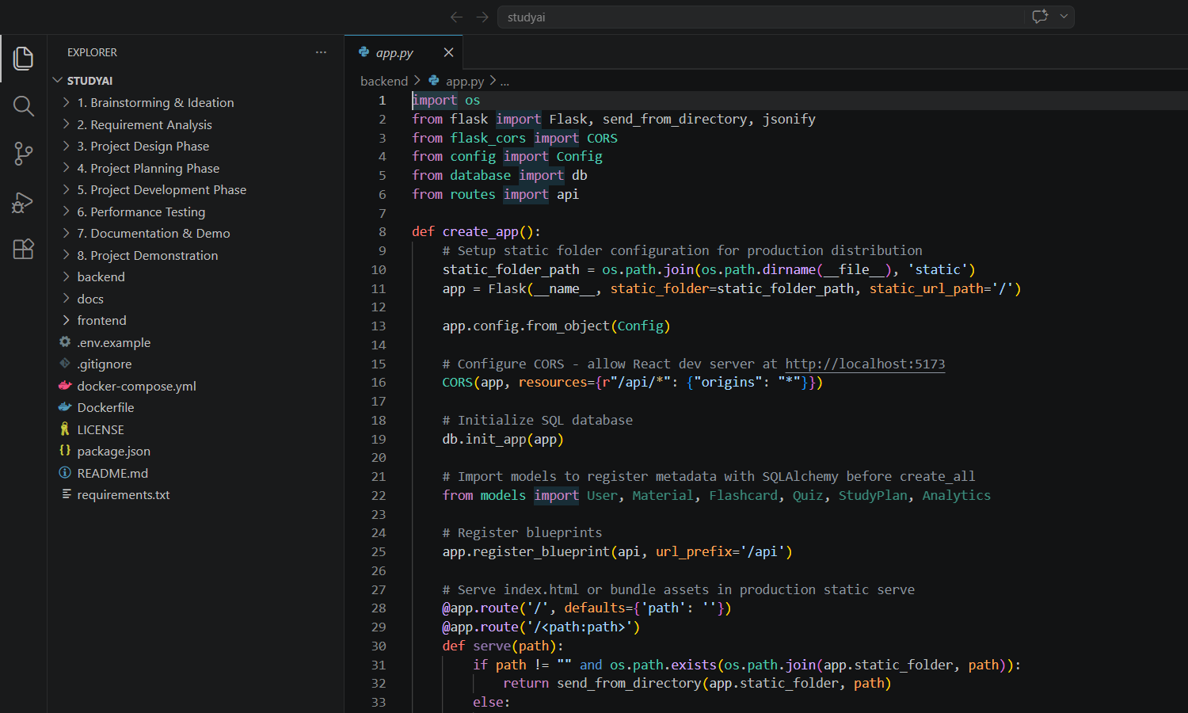

Figure 6.1: StudyAI Development Environment

Project Workflow

Introduction
The StudyAI project follows a structured software development workflow beginning with requirement analysis and ending with deployment and validation. Each phase contributes to building a reliable AI-powered study platform that supports intelligent learning, quiz generation, flashcards, summaries, and personalized study schedules.

Workflow Steps
- Requirement Analysis
- System Architecture Design
- Development Environment Setup
- AI Service Integration (Groq API)
- Frontend Development (React.js)
- Backend Development (Flask)
- Firebase Database & Storage Integration
- Study Material Upload & Processing
- AI Summary Generation
- Flashcard Generation
- Quiz Generation & Evaluation
- Personalized Study Plan Generation
- Testing & Validation
- Deployment

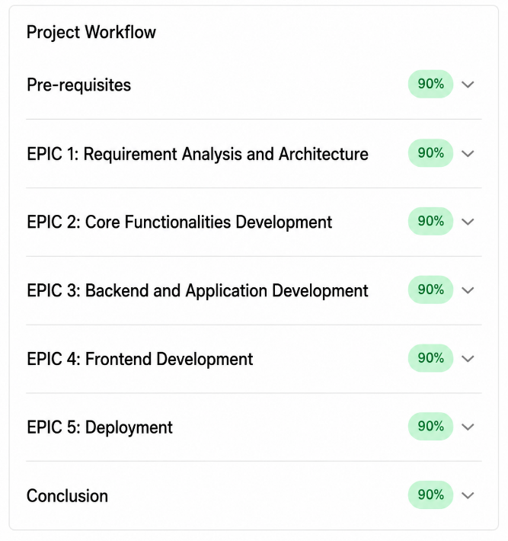

7.1: StudyAI Project Workflow

Description
The workflow begins with collecting study materials from users and storing them securely in Firebase. The Flask backend processes requests and communicates with the Groq AI model to generate summaries, flashcards, quizzes, and personalized study plans. Finally, the generated content is presented through the React-based user interface, providing students with an interactive learning experience.

Milestones
1. Pre-requisites
- Install required software and tools
- Configure Groq API
- Configure Firebase services
- Set up the development environment
2. Milestone 1: Requirement Analysis and Architecture
- Generate and configure the Groq AI API key
- Configure required accounts and cloud services
- Research and select the Llama 3.3 70B Versatile AI model
- Design the application architecture
- Prepare the development environment
3. Milestone 2: Core Functionalities Development
- Develop study material upload functionality
- Implement AI summary generation
- Develop AI flashcard generation
- Implement AI quiz generation
- Generate personalized study schedules
4. Milestone 3: Backend and Application Development
- Implement the Python Flask backend
- Develop REST API services
- Integrate Firebase database and storage
- Integrate Groq AI services
- Develop the main application logic
5. Milestone 4: Frontend Development
- Design and develop the React user interface
- Create responsive web pages
- Implement dynamic content rendering
- Connect frontend with backend APIs
6. Milestone 5: Deployment
- Prepare the application for local deployment
- Deploy frontend and backend services
- Validate the live application workflow
- Perform final integration testing
7. Conclusion
- Review completed project functionalities
- Document project outcomes
- Identify future enhancements
- Final project testing and documentation
Milestone 1: Requirement Analysis and Architecture

Introduction
The Requirement Analysis and Architecture phase focuses on understanding the project objectives, identifying user requirements, selecting appropriate technologies, and designing the overall system architecture. During this milestone, the AI services, cloud database, development tools, and application workflow were planned to ensure scalable, secure, and efficient implementation of the StudyAI platform.

Activity 1.1: Configure AI Services and Development Environment
The StudyAI application integrates the Groq API with the Llama 3.3 70B Versatile language model to provide AI-powered summarization, flashcard generation, quiz creation, and personalized study scheduling. Firebase services were configured for cloud storage and database management, while the development environment was prepared using React.js, Python Flask, Visual Studio Code, and GitHub for collaborative development.

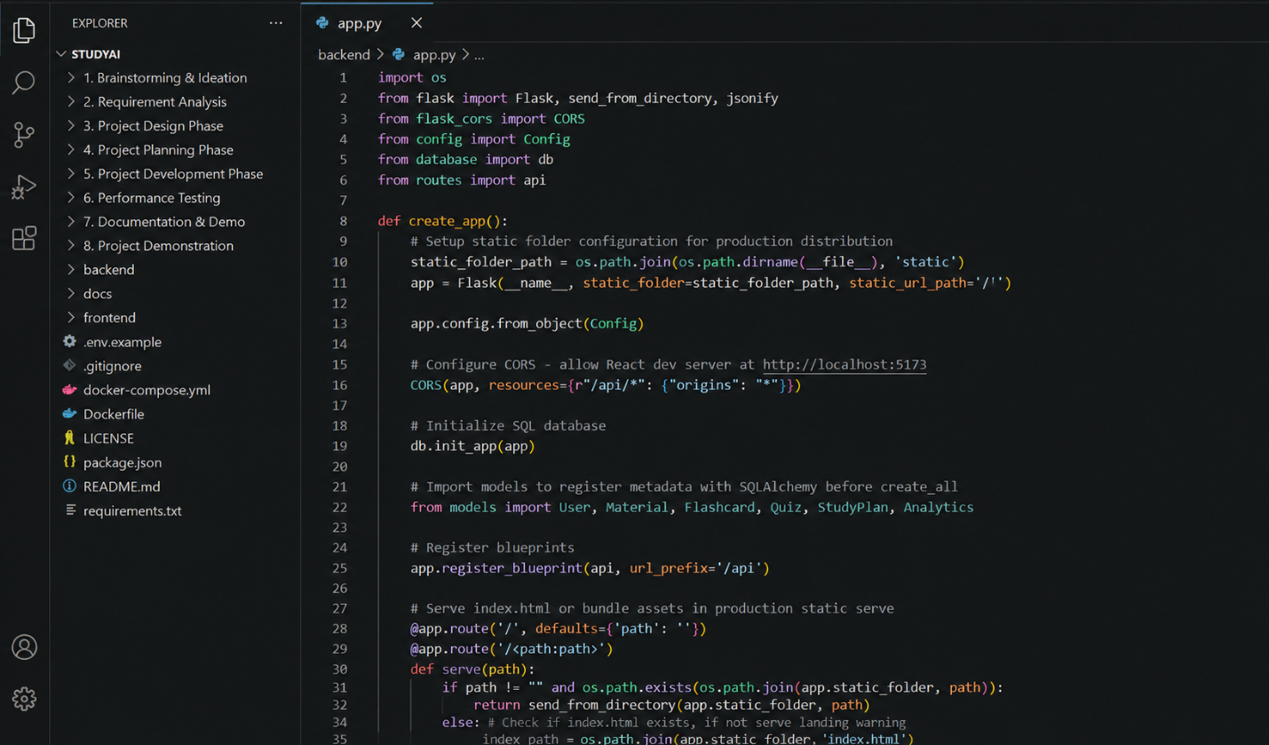

Figure 5.1: StudyAI Development Environment

Activity 1.2: Design the System Architecture
The overall system architecture was designed to establish communication between the React frontend, Flask backend, Firebase database, Firebase Storage, and Groq AI services. The architecture enables users to upload study materials, process AI requests securely, store learning progress, and generate intelligent educational content through REST APIs.

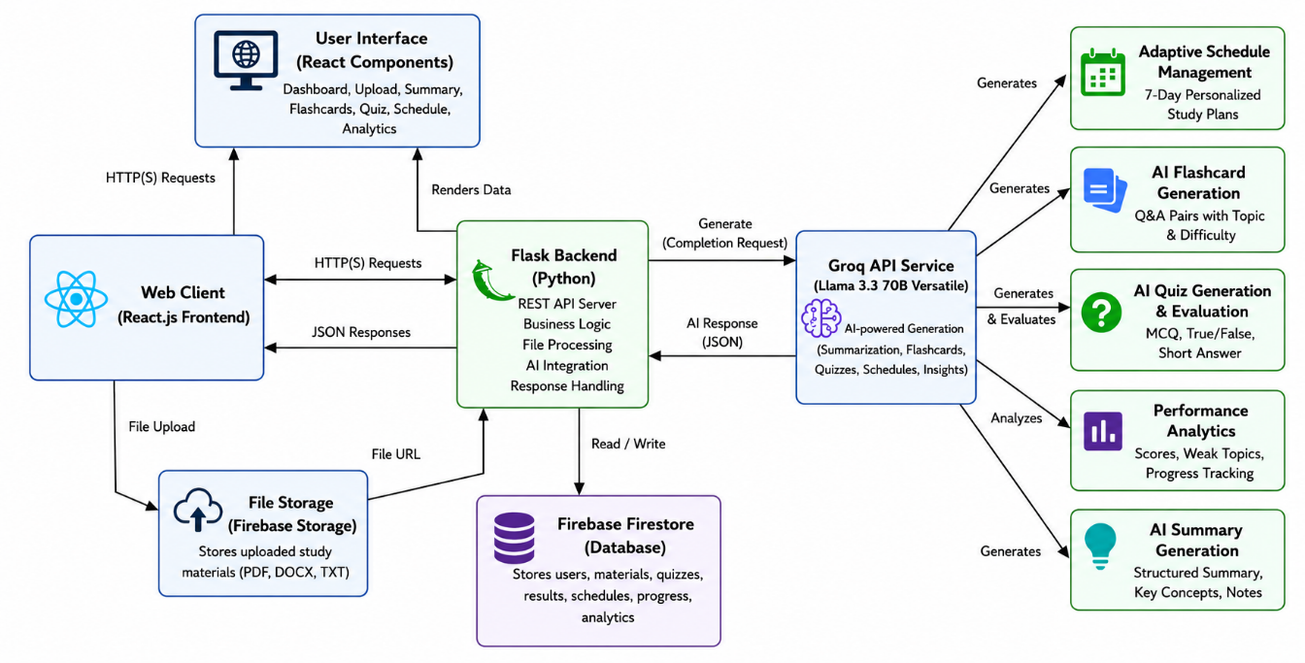

Figure 5.2: StudyAI System Architecture

Activity 1.3: Define the Project Workflow
The project workflow was organized into multiple milestones including requirement analysis, core functionality development, backend implementation, frontend development, deployment, testing, and documentation. This structured workflow ensured systematic development and efficient project management throughout the implementation process.
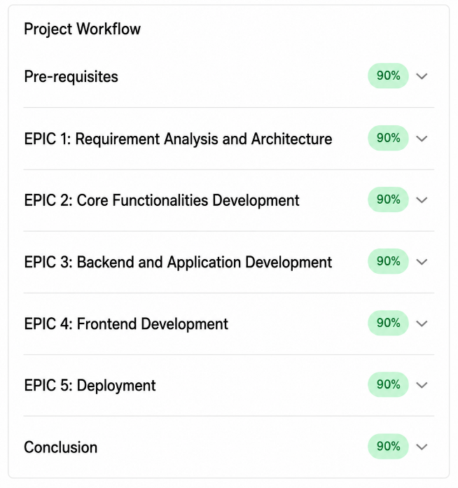

Figure 5.3: StudyAI Project Workflow

Description
The StudyAI project architecture provides a complete AI-powered learning platform where users can upload study materials, generate summaries, create flashcards, attempt quizzes, and receive personalized study schedules. The integration of React.js, Flask, Firebase, and Groq AI enables secure data management, intelligent content generation, and a responsive user experience.

Milestone 2: Core Functionalities Development
Introduction
The Core Functionalities Development phase focuses on implementing the essential AI-powered learning features of the StudyAI application. During this milestone, modules for study material upload, AI-generated summaries, flashcard generation, quiz creation, and personalized study scheduling were developed. These features provide students with an intelligent platform for organizing study materials, improving learning efficiency, and preparing effectively for examinations.

Activity 2.1: Develop Core AI Study Companion Features
The core modules were developed to enable students to upload study materials, generate concise summaries, create interactive flashcards, attempt AI-generated quizzes, and receive personalized study schedules. The application provides an intuitive dashboard where users can easily access all learning features through a responsive and user-friendly interface.

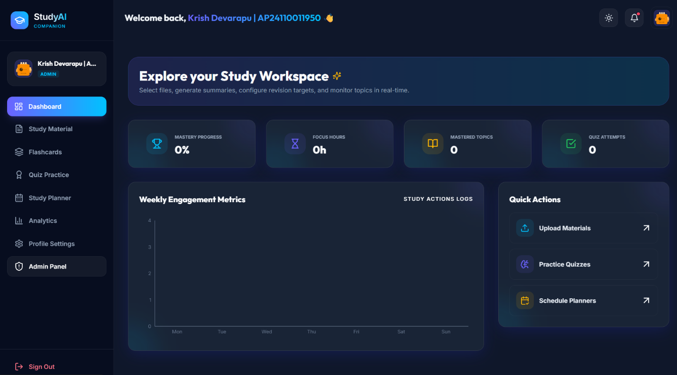

Figure 8.1: StudyAI Dashboard

Study Material Upload
The Study Material Upload module allows users to upload PDF, DOCX, or TXT files, or directly paste study content into the application. Uploaded materials are securely stored and assigned unique identifiers, making them available for AI-powered processing including summary generation, flashcards, quizzes, and study planning.

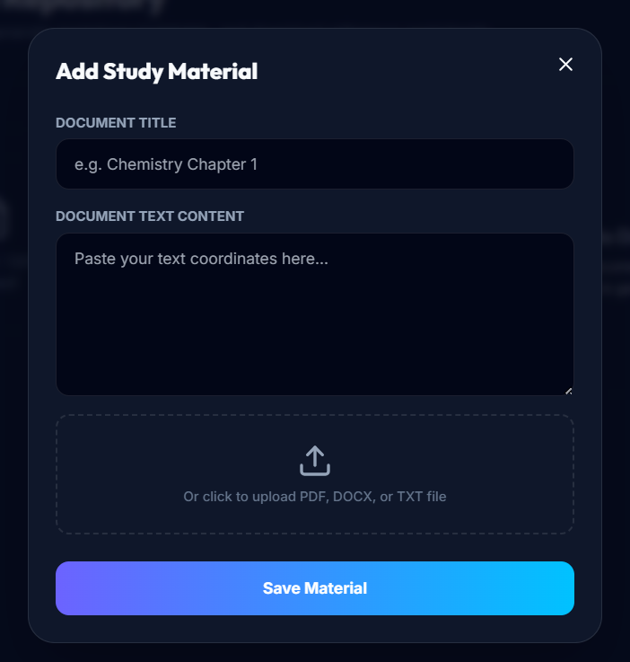

Figure 8.2: Study Material Upload Module

AI Summary Generation
The AI Summary module uses the Groq API with the Llama 3.3 70B Versatile model to analyze uploaded study materials and generate structured summaries. The generated content includes topic overviews, key concepts, important definitions, core principles, and revision notes that help students understand subjects quickly.

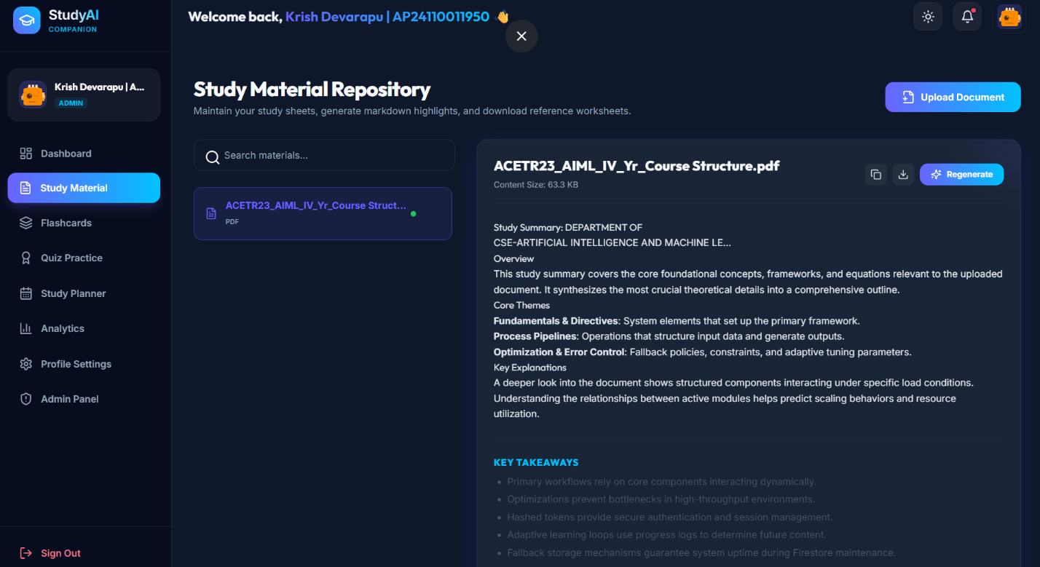

Figure 8.3: AI Summary Generation

AI Flashcard Generation
The Flashcard module automatically creates question-and-answer flashcards from uploaded study materials. Students can flip cards, shuffle the deck, mark mastered concepts, and review important topics through interactive learning sessions.

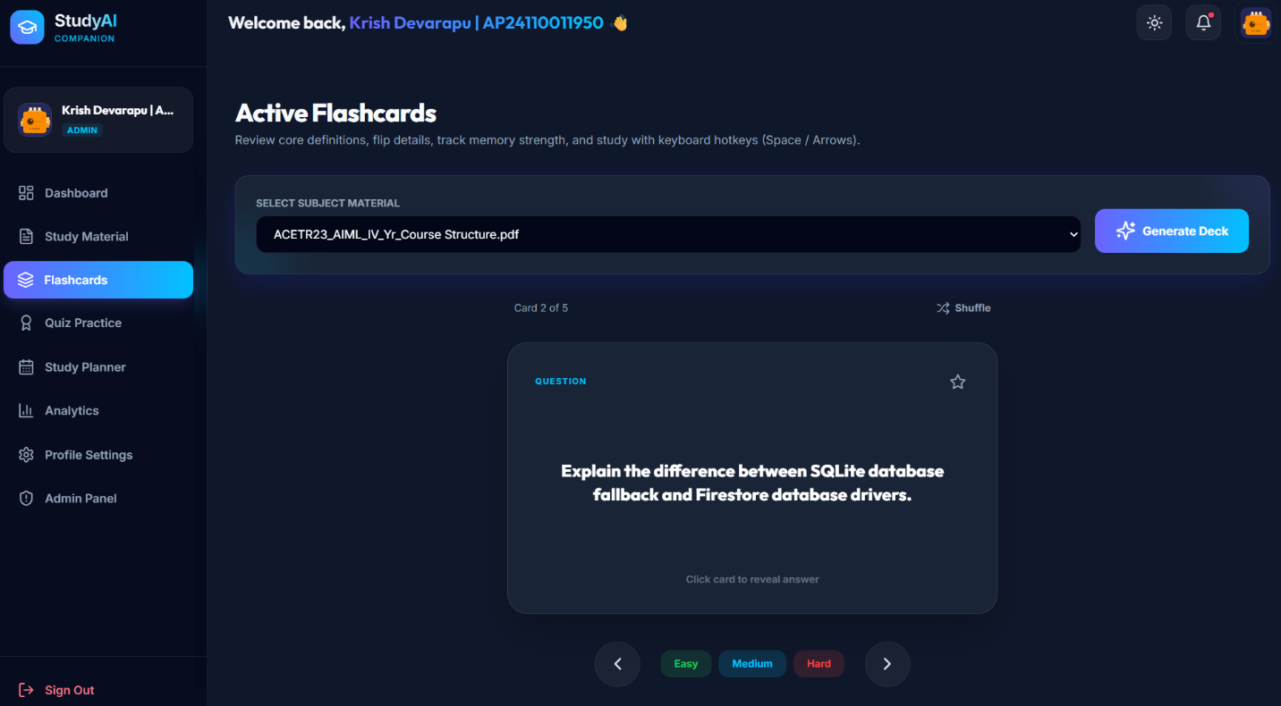
Figure 8.4: AI Flashcard Generation
AI Quiz Generation
The Quiz module enables students to generate AI-powered quizzes using multiple formats such as multiple-choice questions, true/false questions, and short-answer questions. After completion, the system evaluates responses, calculates scores, highlights weak topics, and provides detailed explanations.

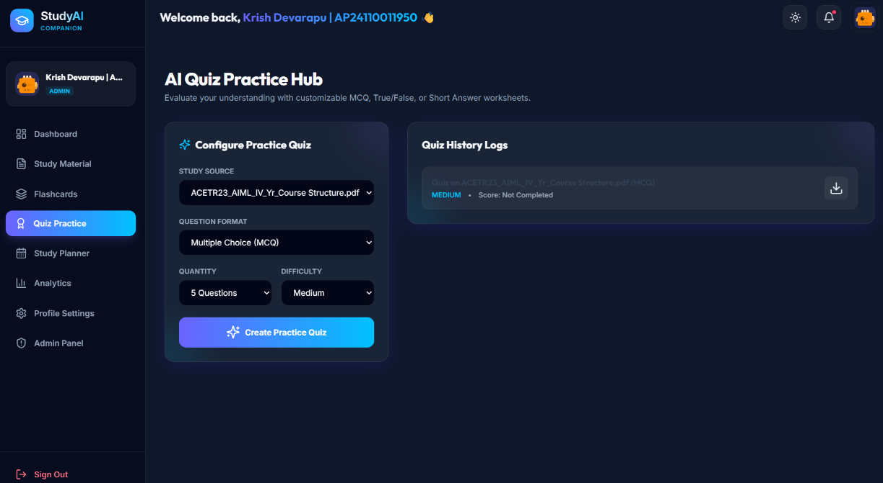

Figure 8.5: AI Quiz Generation
Personalized Study Schedule
The Study Schedule module generates a personalized 7-day learning plan based on uploaded materials and quiz performance. It recommends daily study tasks, focus topics, and revision schedules to help students prepare effectively.

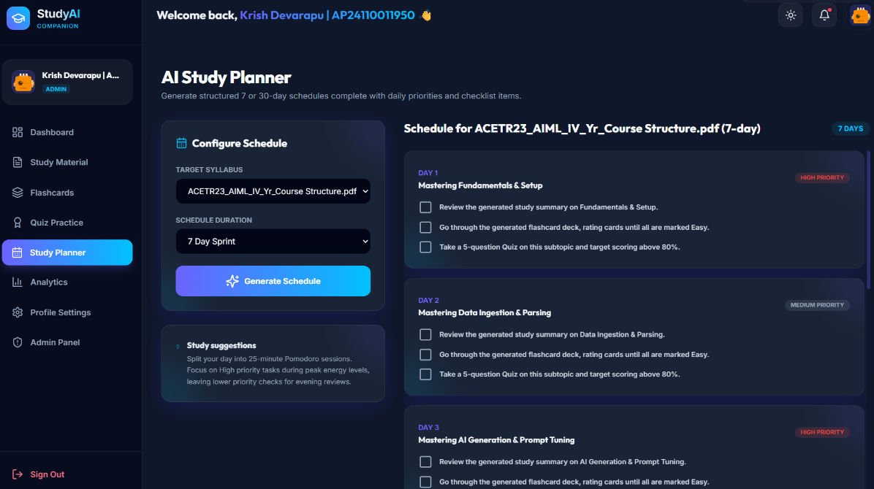

Figure 8.6: Personalized Study Schedule

Milestone 3: Backend and Application Development

Introduction
The Backend and Application Development phase focuses on implementing the server-side logic, AI integration, database communication, and application workflow. During this milestone, the Flask backend, REST APIs, Firebase integration, and Groq AI services were developed to process study materials, generate AI-powered educational content, and manage application data securely.

Activity 3.1: Writing the Main Application Logic
The main application logic coordinates communication between the React frontend, Flask backend, Firebase database, and Groq AI services. It processes uploaded study materials, validates user requests, manages AI operations, and returns generated summaries, flashcards, quizzes, and personalized study schedules through REST APIs.

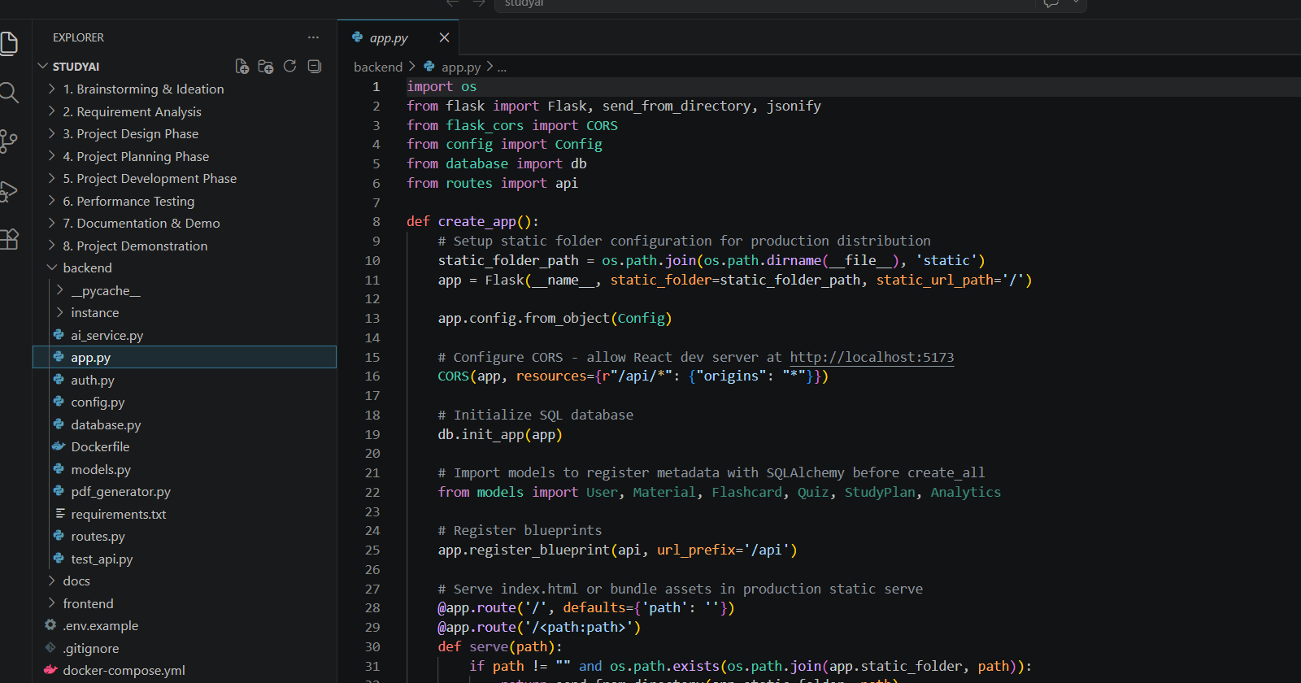

Figure 9.1: Main Backend Application Logic (app.py)

Activity 3.2: AI Study Summary Integration
The StudyAI application integrates the Groq API using the Llama 3.3 70B Versatile model to generate intelligent study content. The backend sends uploaded study material to the AI model, which returns structured summaries, flashcards, quizzes, and personalized study plans, improving students' learning experience.

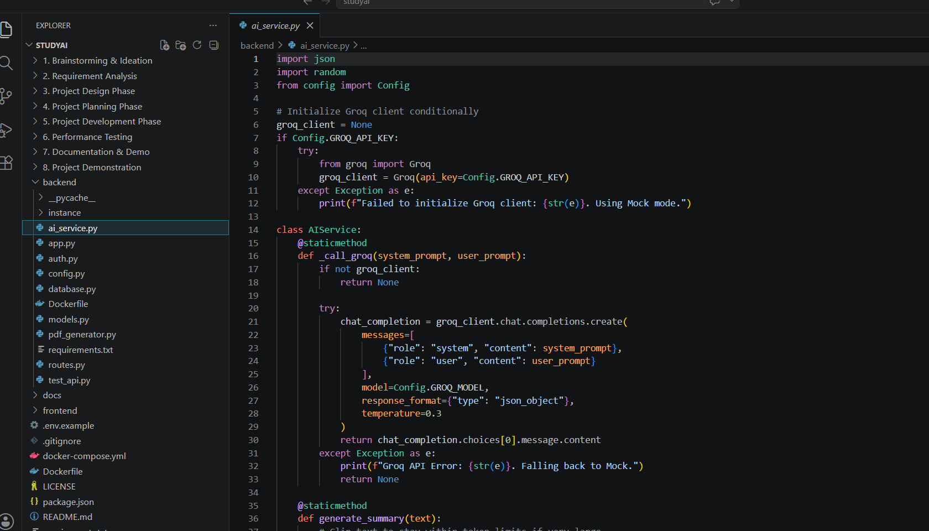
Figure 9.2: AI Study Content Generation

Description
The backend architecture enables seamless communication between the frontend, database, and AI services. The Flask application manages API requests, performs AI processing, stores study data securely, and delivers personalized educational content efficiently.

Milestone 4: Frontend Development
Introduction
The Frontend Development phase focuses on designing and implementing a modern, responsive, and user-friendly interface for the StudyAI application. The frontend was developed using React.js to provide students with an interactive platform for uploading study materials, generating AI-powered summaries, creating flashcards, taking quizzes, viewing analytics, and managing personalized study schedules. The interface ensures smooth navigation, responsive layouts, and seamless communication with the Flask backend.

Activity 4.1: Designing and Developing the User Interface
The StudyAI user interface was developed using React.js with a clean and responsive design. The application provides a structured navigation menu, dashboard, study material management, AI summary generation, flashcards, quiz practice, analytics, and study planner modules. The consistent layout improves usability and allows students to access all learning features from a single platform.



Figure 10.1: StudyAI Dashboard

Activity 4.2: Creating Dynamic Content Rendering with React
React components dynamically render study materials, AI-generated summaries, flashcards, quizzes, analytics, and personalized study schedules without requiring full page reloads. The frontend communicates with the Flask backend through REST APIs to display updated information instantly, providing a smooth and interactive learning experience.

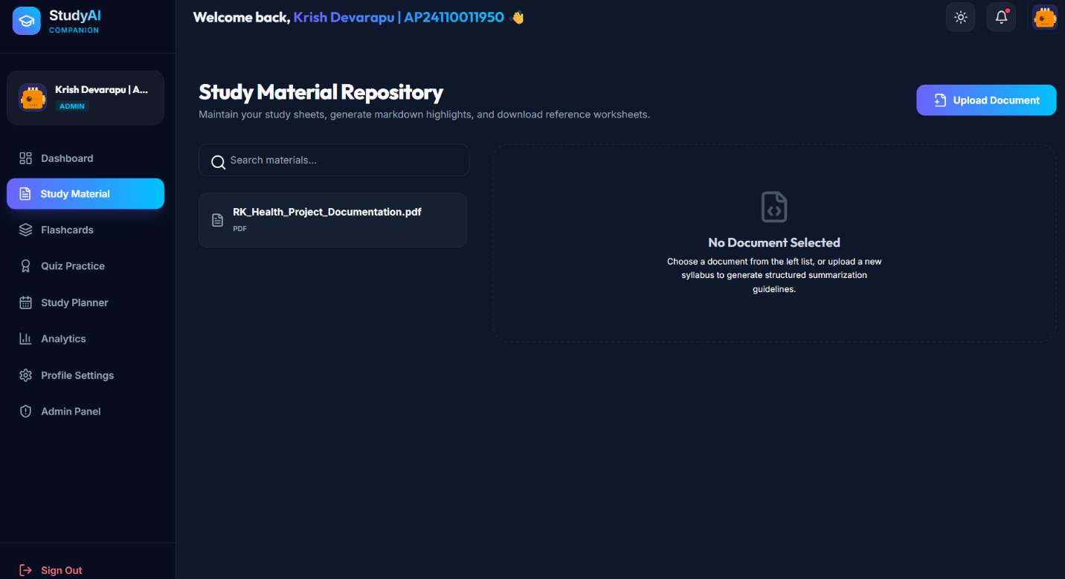

Figure 10.2: Study Material Management

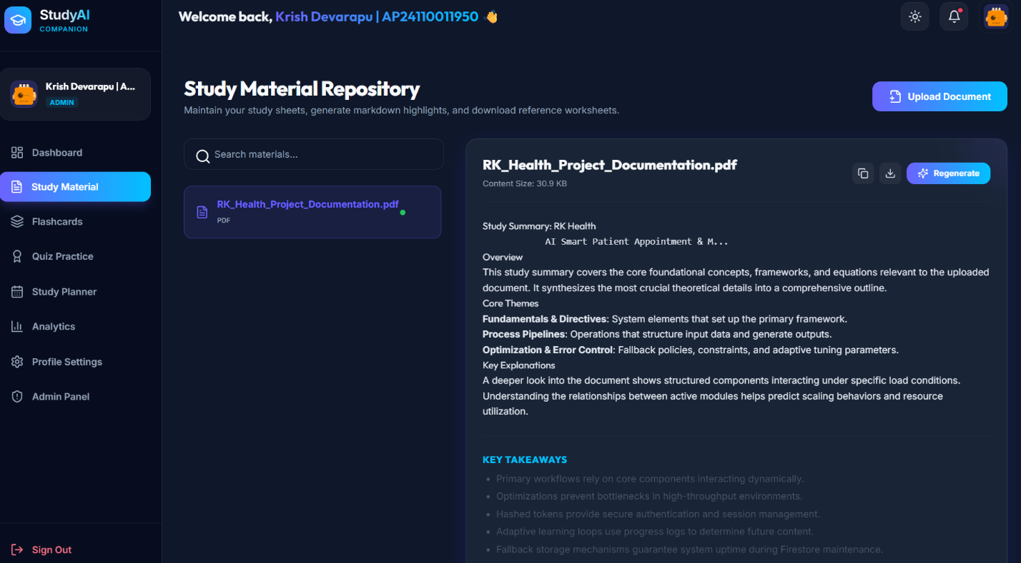

Figure 10.3: AI Summary Generation

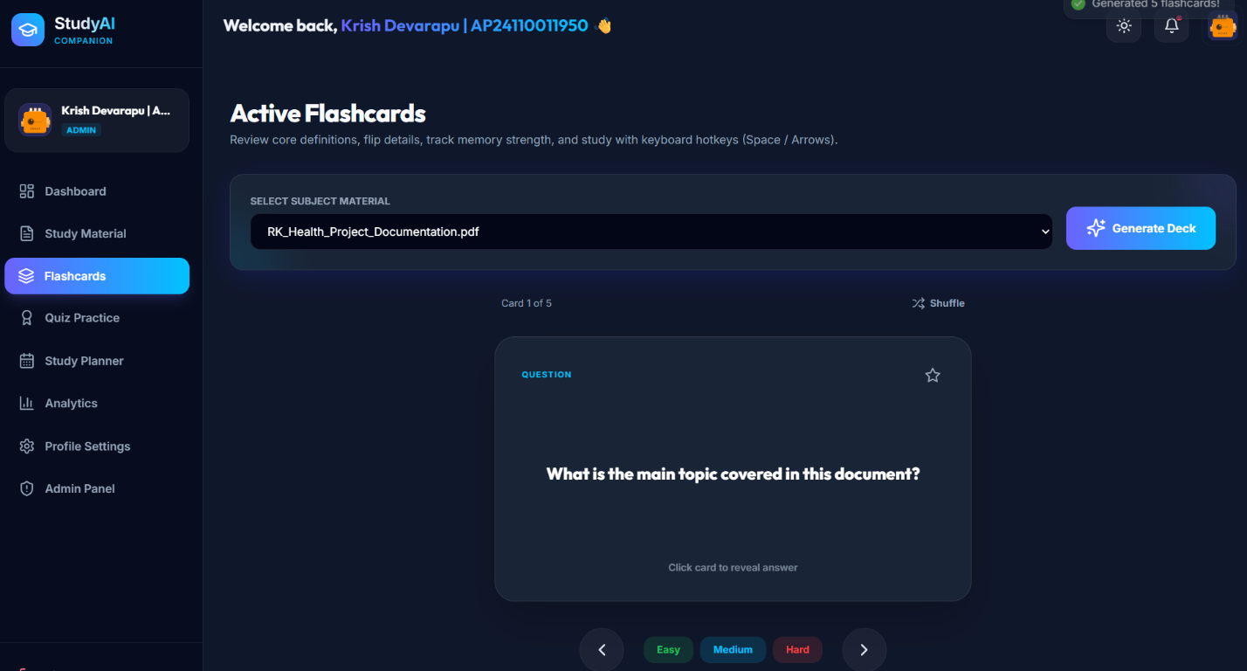

Figure 10.4: AI Flashcard Generation

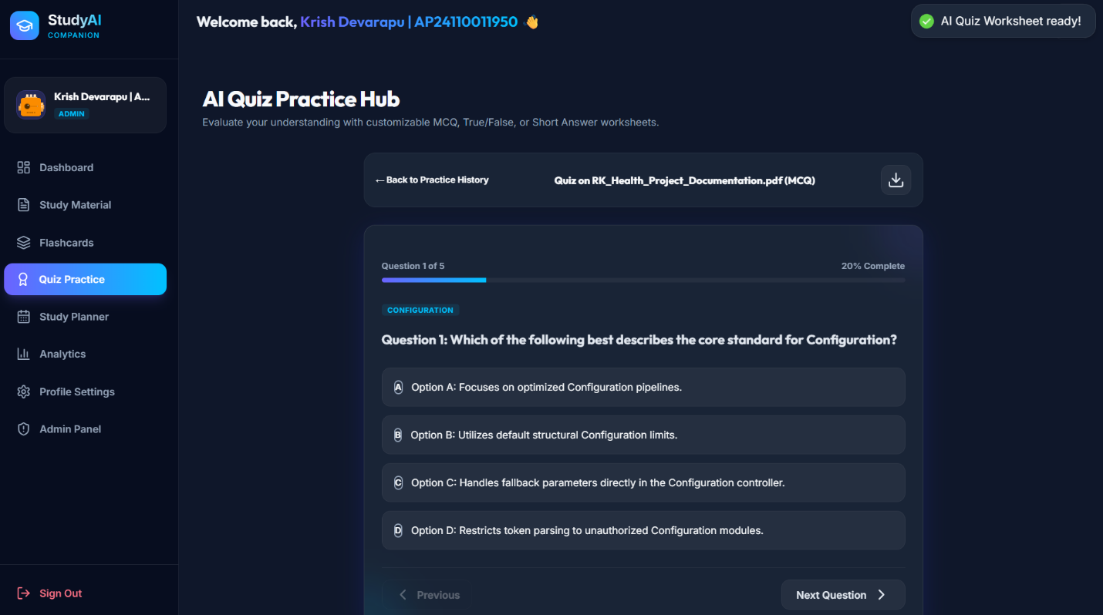

Figure 10.5: AI Quiz Interface

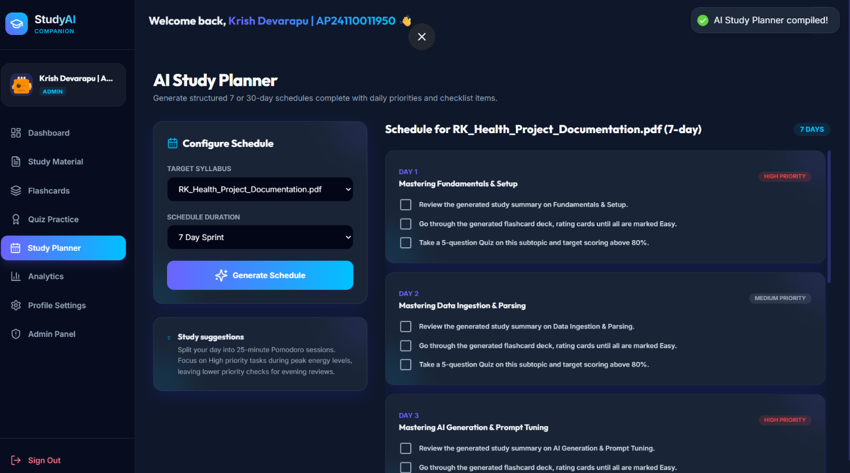

Figure 10.6: Personalized Study Schedule

Description
The React-based frontend dynamically communicates with the Flask backend to display AI-generated educational content in real time. Students can upload study materials, generate summaries, practice with flashcards, take quizzes, analyze performance, and follow personalized study schedules through a responsive interface. The application delivers a seamless and engaging learning experience across different devices.

Milestone 5: Deployment
Introduction
The Deployment phase focuses on preparing the StudyAI application for production and validating its functionality in a live environment. During this milestone, the frontend, backend, Firebase services, and Groq AI integration were configured, tested, and deployed to ensure reliable performance. The deployed application enables students to access AI-powered study tools through a web browser with secure communication between all application components.

Activity 5.1: Preparing the Application for Deployment
The StudyAI project was prepared for deployment by organizing the project structure, configuring environment variables, installing required dependencies, and verifying communication between the React frontend, Flask backend, Firebase services, and Groq AI platform. Proper configuration ensures smooth application execution and simplifies future maintenance.

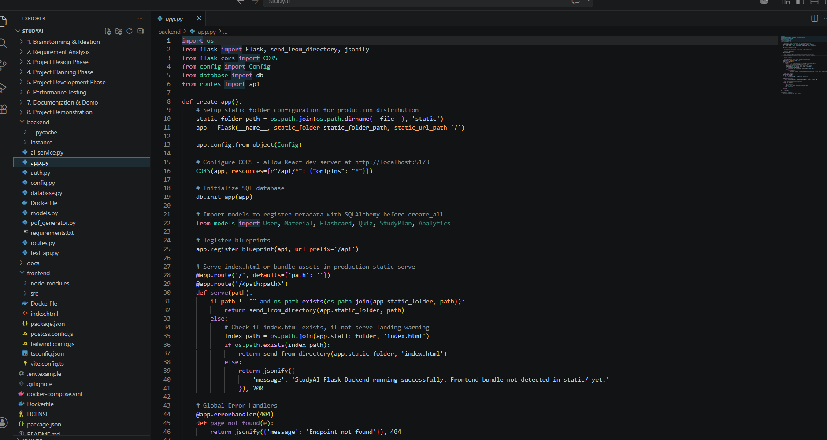

Figure 11.1: StudyAI Project Structure

Activity 5.2: Deploying the Application
The complete project source code was maintained using GitHub for version control and collaborative development. The application components were deployed to enable real-time access to AI-powered learning features. Deployment ensured secure communication between the frontend, backend, Firebase cloud services, and Groq AI.

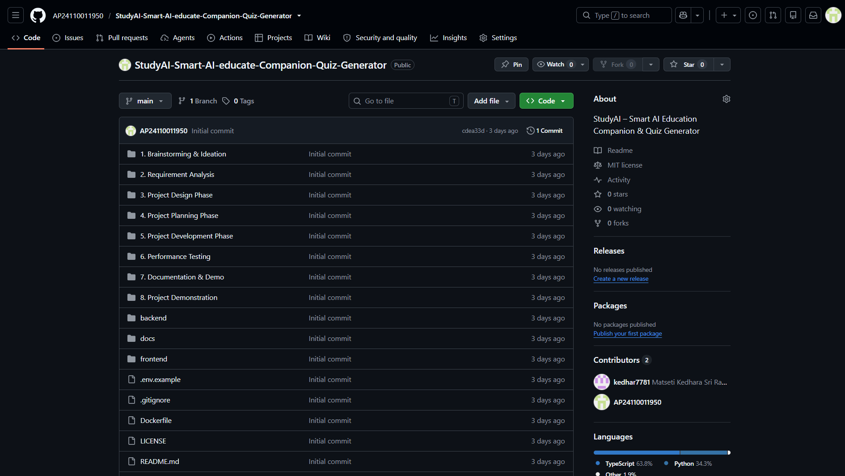
Figure 11.2: GitHub Repository Deployment

Backend Deployment
The Flask backend was configured to manage API requests, AI processing, study material handling, Firebase communication, and cloud services. Backend modules coordinate AI-powered summary generation, flashcard creation, quiz generation, analytics, and personalized study planning while ensuring secure data processing.

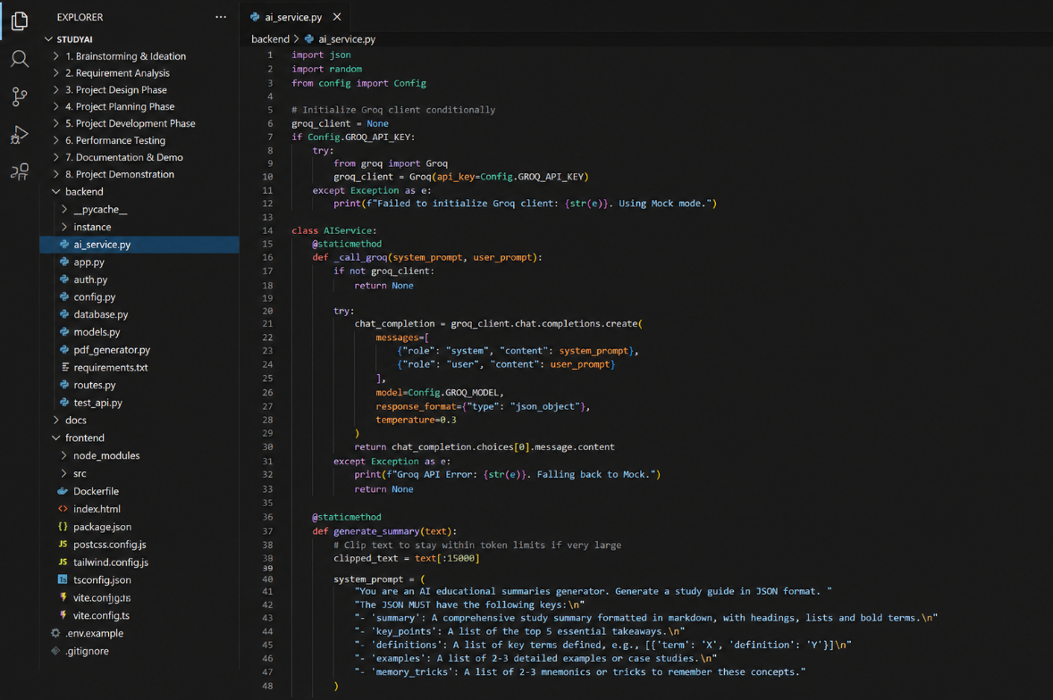

Figure 11.3: Backend AI Service Integration
Activity 5.3: Validate Deployment and Test Live Workflow
Comprehensive testing was performed after deployment to verify study material uploads, AI summary generation, flashcard creation, quiz generation, analytics, and personalized study schedule generation. The deployed application successfully completed functional testing and demonstrated stable performance across all major learning modules.
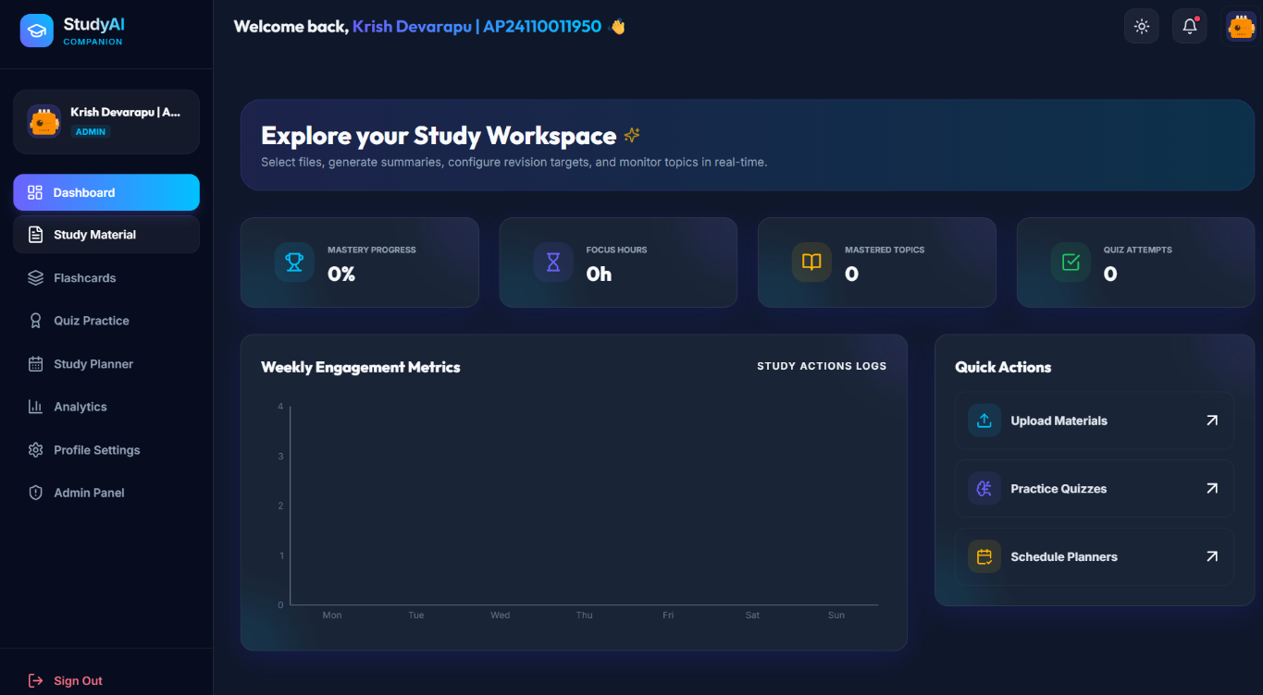

Figure 11.4: Live Application Validation

Description
The deployment process ensured successful integration of the React frontend, Flask backend, Firebase cloud platform, and Groq AI services. Functional testing confirmed reliable application performance, secure data communication, responsive user interaction, and accurate AI-generated educational content. The deployed system provides students with a stable and intelligent learning platform.

Conclusion
The StudyAI project was successfully developed as an AI-powered educational platform that helps students improve their learning through intelligent study tools. The application enables users to upload study materials, generate AI-powered summaries, create flashcards, practice quizzes, analyze learning performance, and receive personalized study schedules through a single web-based interface.
The project integrates React.js, Python Flask, Firebase, and the Groq AI platform to provide fast, accurate, and interactive educational content. Throughout the project, all major software development phases—including requirement analysis, system design, implementation, testing, deployment, and documentation—were successfully completed.
The application demonstrates how Generative AI can simplify exam preparation and personalized learning while providing an efficient, responsive, and user-friendly experience. Future enhancements may include collaborative learning, multilingual support, mobile application deployment, offline learning capabilities, and advanced AI-powered learning analytics.

Activity 6.1: Final Documentation, Testing, and Review
The StudyAI project was successfully completed following a structured software development lifecycle that included requirement analysis, system design, implementation, testing, deployment, and documentation. All functional modules were verified, screenshots were documented, deployment was validated, and the complete project workflow was reviewed to ensure accuracy, consistency, and readiness for project evaluation.

